Problem Statement:Define an application to find the area and perimeter of various shapes.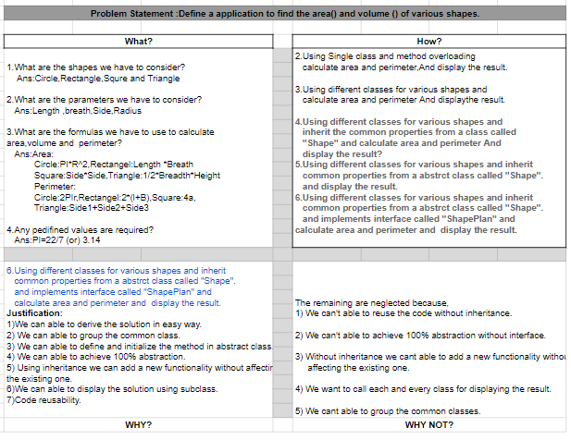

Algorithm:

Step 1:Start.

Step 2:Create a “ShapePlan” interface class.

Step 3:Define a method for area and perimeter.

Step 4:Create an abstract class called “Shape” and implement it to

ShapePlan.

Step 5:Declare the parameters.

Step 6:Create a subclass for Circle,Rectangle,Square,Triangle.

Step 7:Declare and define methods for area and perimeter in each class.

Step 8:In the main class by creating an object ,call the methods area and perimeter for each shape.

Step 9:Display the results.

Step 10:Stop.

**Code:**

**package** com.jeban.practice;

**interface** ShapePlan {

**void** area();

**void** perimeter();

**final** **double** ***PI*** = 3.14;

}

**abstract** **class** Shape **implements** ShapePlan {

**public** **void** area() {

}

**public** **void** perimeter() {

}

}

**class** Circle **extends** Shape {

**int** radius;

Circle(**int** radius) {

**this**.radius = radius;

}

**public** **void** area() {

**double** area = ***PI*** * radius * radius;

System.***out***.println("Area of Circle is:"+area);

}

**public** **void** perimeter() {

**double** perimeter = 2 * ***PI*** * radius;

System.***out***.println("Perimeter of Circle is:"+perimeter);

}

}

**class** Rectangle **extends** Shape {

**int** length;

**int** breath;

Rectangle(**int** length, **int** breath) {

**this**.length = length;

**this**.breath = breath;

}

**public** **void** area() {

**double** area = length * breath;

System.***out***.println("Area of Rectangle is:"+area);

}

**public** **void** perimeter() {

**double** perimeter = 2 * (length + breath);

System.***out***.println("Perimeter for Rectangle is:"+perimeter);

}

}

**class** Square **extends** Shape {

**int** side;

Square(**int** side) {

**this**.side = side;

}

**public** **void** area() {

**double** area = side * side;

System.***out***.println("Area of Square is:"+area);

}

**public** **void** perimeter() {

**double** perimeter = 4 * side;

System.***out***.println("Perimeter of Square is:"+perimeter);

}

}

**class** Triangle **extends** Shape {

**int** side1;

**int** side2;

**int** side3;

**int** hight;

**int** breath;

Triangle(**int** side1, **int** side2, **int** side3, **int** hight, **int** breath) {

**this**.side1 = side1;

**this**.side2 = side2;

**this**.side3 = side3;

**this**.hight = hight;

**this**.breath = breath;

}

**public** **void** area() {

**double** area = 1 / 2 * breath * hight;

System.***out***.println("Area of Triangle is:"+area);

}

**public** **void** perimeter() {

**double** perimeter = side1 + side2 + side3;

System.***out***.println("Perimeter of Triangle is:"+perimeter);

}

}

**public** **class** ProblemSolving {

**public** **static** **void** main(String[] args) {

Circle circ = **new** Circle(12);

circ.area();

circ.perimeter();

Rectangle rect = **new** Rectangle(10, 20);

rect.area();

rect.perimeter();

Square squ=**new** Square(4);

squ.area();

squ.perimeter();

Triangle tri=**new** Triangle(10,12,4,6,7);

tri.area();

tri.perimeter();

}

}